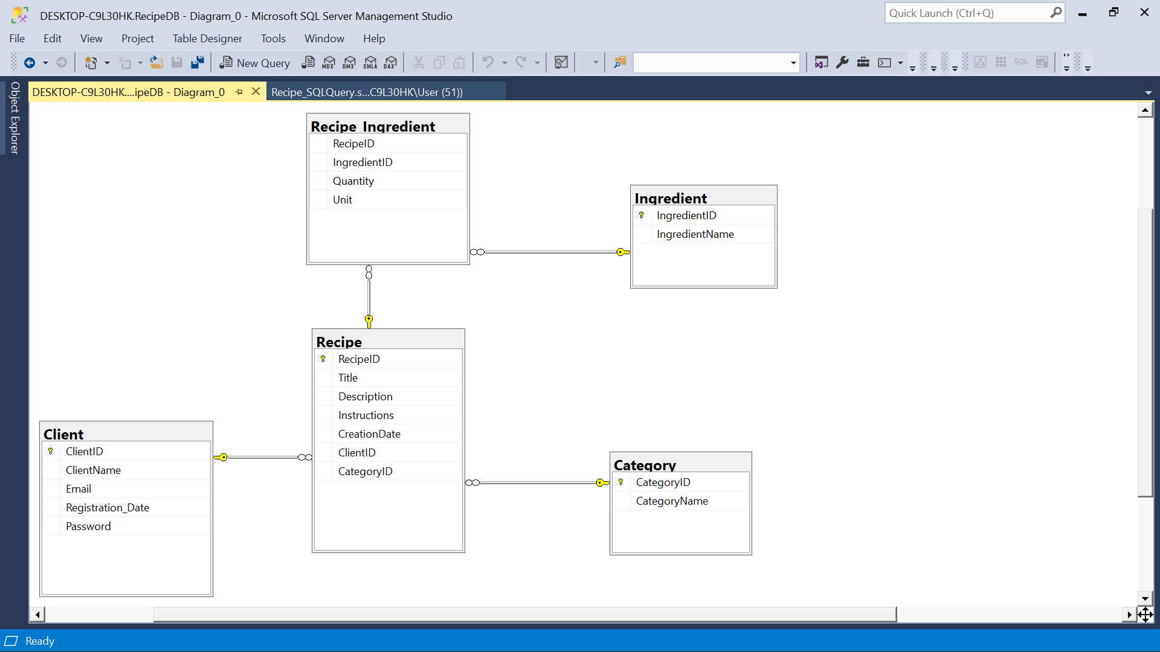

|  |  |  |
| --- | --- | --- |
| **Relationship** | **Type** | **Description** |
| Client — Recipe | 1-to-Many | One client can create many recipes;  each recipe is created by one client . |
| Recipe — Recipe_Ingredient | 1-to-Many | One recipe has many Recipe_Ingredient entries (one per ingredient). |
| Ingredient — Recipe_Ingredient | 1-to-Many | One ingredient can appear in many Recipe_Ingredient entries (across many recipes). |
| Recipe — Category | Many-to-1 | Each recipe belongs to one category;  a category can have many recipes. |

Recipe_Ingredient is junction entity that resolves the many-to-many relationship between Recipe and Ingredient, while also storing the quantity and units for each ingredient in a recipe.